To ENG. Ayman Shaltout




25.10.2018

EgyCut6025PW

CNC CUTTING MACHINE OFFER

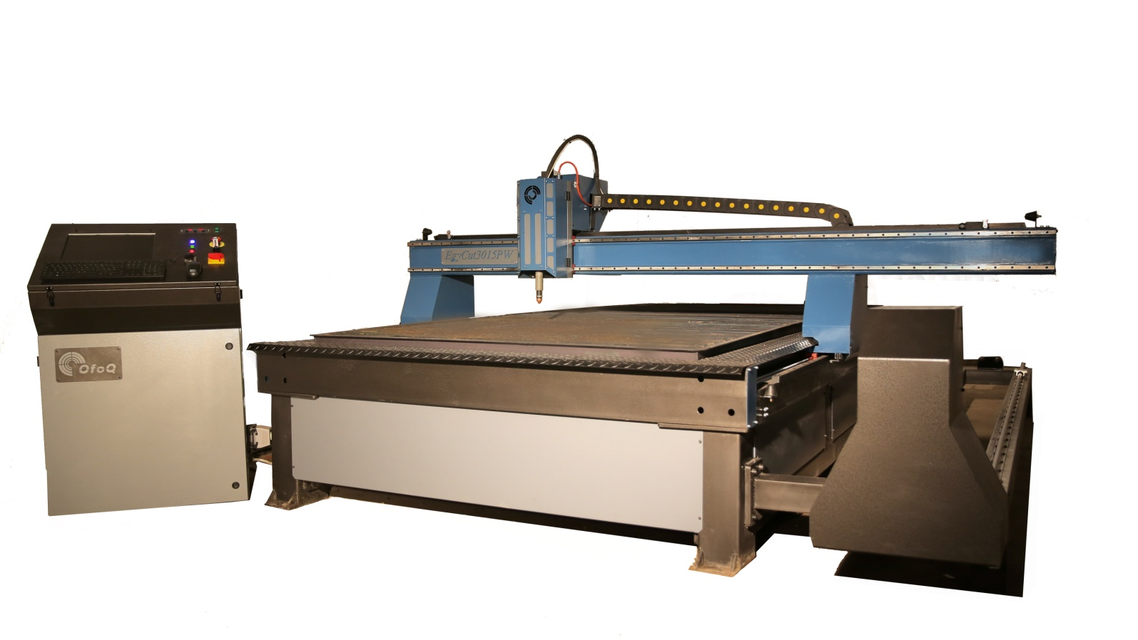
ABOUT OFOQ

We are the Egyptian company OFOQ for consultancies (Ltd.); we are specialized in manufacturing of CNC plasma tables to meet requirement the local and global market.

More than 6-year of manufacturing experience, remaining Ofoq at its quality with European safety standards and quality control management system, implementing international production standard and norms, well equipped technicians and following technological developments, OFOQ presents cost-efficient machineries in sheet metal working and fabrication industry.

OFOQ is the exclusive distributor for Cebora products (plasmas and welders) in Egypt
and North Africa.

We provide the best consumables for plasma machines to get the highest quality and production with the lowest cost.

OFOQ gives a two year warranty for all supported products.

We hope to hear from you soon.

STANDARD EQUIPMENTS

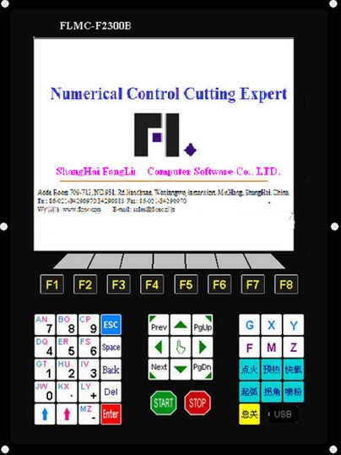
CNC control system FLMC

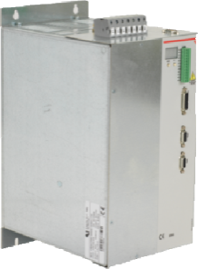

- Plasma source 130A
- Cebora – Italy

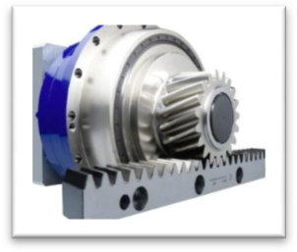
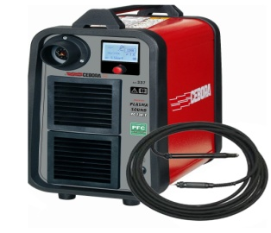

- Baring
HIWIN –

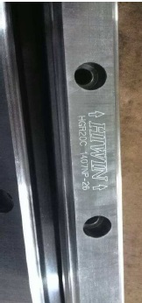
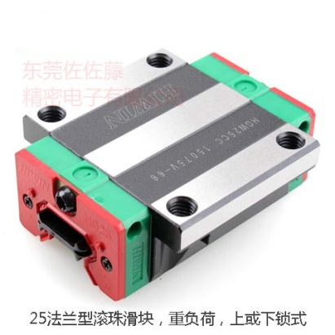

- THC SYSTEM
- Ofoq-Egypt
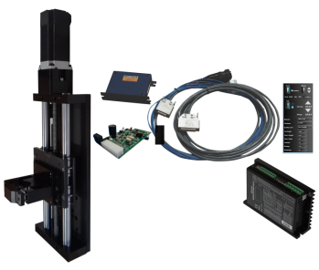
- with DC motor 24V

- stepper Motors
12 N With gearbox (1:5)

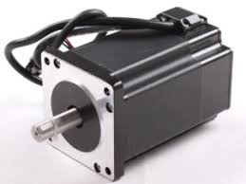

- CNC CONTROLLER
- RACK PINION&GEARBOX HIWIN

- Rails
HIWIN
- 25MM Y-AXIS
- 20MM X-AXIS

- INTRODUCTION

EgyCut CNC plasma durable, versatile, and efficient.

EgyCut Series Plasma was made just for you. With a rugged and rigid all-steel plate frame, you can easily support any standard or high-definition plasma unit you need. The heavy-duty steel frame also means you experience almost no vibration when cutting, which means you get a highly precise cut every time.

. Advantages;
- High-speed contouring.
- Fully programmable retract between parts.
- Automatic initial pierce height.
- Adaptive Automatic Torch Height Control (ATHC).

- MACHINE FEATURES

  - GENERAL INFORMATION

Machine Model | EgyCut6025PW

Plasma source | Plasma sound pc130/T
Metal Type | Mild Steel | Stainless Steel | Aluminum
Cutting Capacity | 25 mm | 20 mm | 20 mm

Working Table Size | 6000 x 2500 mm
Working Table Height | 720 mm
Maximum Loading Capacity | 6000 kg

Axial Movements | X- Axis | 2500mm
Axial Movements | Y- Axis | 6000mm
Axes Movement |  | 3 Axes Digital Motor System
Positioning System |  | Rack and Pinion – Stepper motor
Acceleration |  | Customizable
Axes Speeds (X,Y Traverse Speed ) |  | 20 m /min
Positioning Accuracy |  | ±0,005 mm
Repeatability |  | +/-0.002
Z axis Distance Control |  | THC Unit
Control Panel |  | CNC control
Assist Gas |  | Dry Air : 6 Bar
Machine Weight |  | 2300 kg



- Water Table:

A water table drastically reduces dust and stops plate heat war page. Many of our competitors expect you to build your own or pay extra for such a feature. OFOQ offers this standard on every table.

- Adaptive Automatic Torch Height Control (DTHC) (Standard):

Our Advance Torch Height Control allows the torch to raise and lower as it moves over warped plate and diamond plate. It maintains a precise distance off the plate using arc voltage feedback. This increases consumable life, increases cut quality, and lowers your costs. Every system we sell comes with Advanced Torch Height Control standard. Don’t buy a table without it, in fact we won’t sell a table without DTHC.

- High Speed Dual Drive Gantry:

Our gantry is driven on both sides with two powerful motors. This dual drive eliminates gantry flex which allows for fast, clean, accurate cutting. This means:

- Cleaner cuts ( less clean up means more profit)
- More accurate cuts ( less waste and wasted time)
- Faster cut times (faster positioning between cuts reduces cut time dramatically.

- Industrial Cable Chain:

Neatly contained through standard industrial cable chain links is your cabling and wires. Our cable chains give a clean aesthetic look, eliminating the need for overhead arms or unmanaged wiring. The result is unfettered table function and plate loading area.

- Anti collision machine torch:

Sensitive to keep the torch from the fracturing during work when collide by a metal object.

- PLASMA SOUND PC 130/T specification

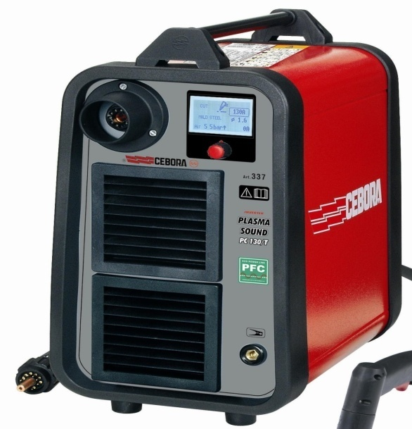
The PLASMA SOUND PC 130/Three-phase power source for plasma cutting of metals represents the upward evolution of the 10051/T.
Thanks to the new aircooled CP 162C torch, the recommended thickness, for the best cutting quality and productivity, is 40 mm; the maximum thickness is 50 mm and the severance thickness is 60 mm.
The duty cycle (125A@100% and 130A@80%) and the cutting speed make the PLASMA SOUND PC 130/T ideal for automatic production applications, as well as for manual productions.

Main features of this model:
- Simple control panel with LCD display
- Synergic parameters settings
- “Pilot self-restart” function selectable from the panel, which interrupts and automatically restarts the arc when cutting nets and grids, increasing operator productivity.
- Consumables worn out automatic detection
- Central torch adapter with safety protection, to avoid accidental contact with the power parts.
- “Post-gas” function which, by cooling the torch after arc shut-off, reduces stress on the components and extends the life-span of consumables.
- Suitable for gouging
- High electromagnetic compatibility, per IEC 60974-10, allowing the power source to be used in the vicinity of electronic equipment (such as computers, PLC, etc).
- Automatic detection of phase presence (both upon start-up and during operation), to avoid damaging the machine in case the phase is accidentally missing.
- Automatic voltage change between 208/220/230V and between 400/440 V.
- Standard equipped with 6 m CP162C MAR torch with "on air" ignition (no high frequency)
- The power source can also be powered by motor-driven generators of adequate power
- Spot marking function for extremely accurate indentation marking

- Technical specification

Art. | 337 |  | Specifications
 | 208-220-230V  50/60 Hz  ± 10% | 400-440V  50/60 Hz  ± 10% | Three phase input
 | 50 A | 32 A | Fuse rating (slow blow)
 | 16,6 KVA 100% | 22 KVA 100% | Input power
 | 20A ÷ 130A | 20A ÷ 130A | Current adjustment range
 | 130A 50%  125A 60%  105A 100% | 130A 80%  130A 100% | Duty Cycle (10 min.40°C)  According to IEC 60974.1
 | ELECTRONIC |  | Stepless regulation
 | 40-50-(60) mm  1”37/64”-1”31/32” (2”-3/8”) |  | Thickness on steel: Recommended- Max.-(Severance)
 | 6m (20 ft.) |  | Torch length
 | 250 lt/min - 5,5 bar |  | Air consumption
 | IP 23 S |  | Protection class
 | 40 Kg |  | Weight
 | 297x613x558H |  | Dimensions mm

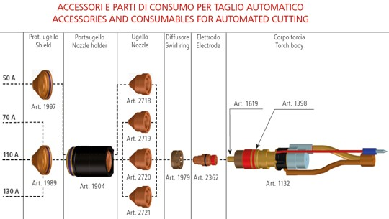
- Accessories and consumables for automated cutting

Art. | Description
1632 | Cebora CP162C DAR torch for profile machine with central adaptor. 6 m long (20 ft).
1632.15 | Cebora CP162C DAR torch for profile machine with central adaptor. 12 m long (50 ft).
1132 | Body for torches for profile machine
1398 | "O-rings" (5 pieces)
2718 | Ø 0.9 mm nozzles (5 pieces). Can be used between 20 and 50 Amp
2719 | Ø 1.35 mm nozzles (5 pieces). Can be used between 51 and 70 Amp
2720 | Ø 1.50 mm nozzles (5 pieces). Can be used between 71 and 110 Amp
2721 | Ø 1.65 mm nozzles (5 pieces). Can be used between 111 and 130 Amp
1989 | Shield
1997 | Shield
2362 | Electrodes (5 pieces). Can be used between 20 and 130 Amp
1904 | Nozzle holder
1979 | Swirl-Ring
1619 | Brass cooling pipes (5 pieces)

PLASMA Cutting / Certifications and Standard.

Declaration of CE conformity

(EMC - LVD - RoHS2 - all applicable standards)

ISO 9001 Certificate

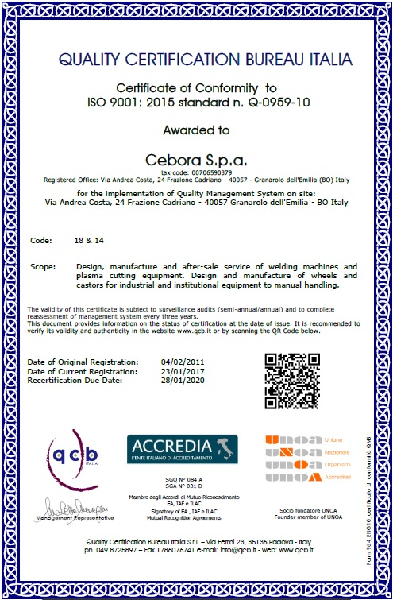
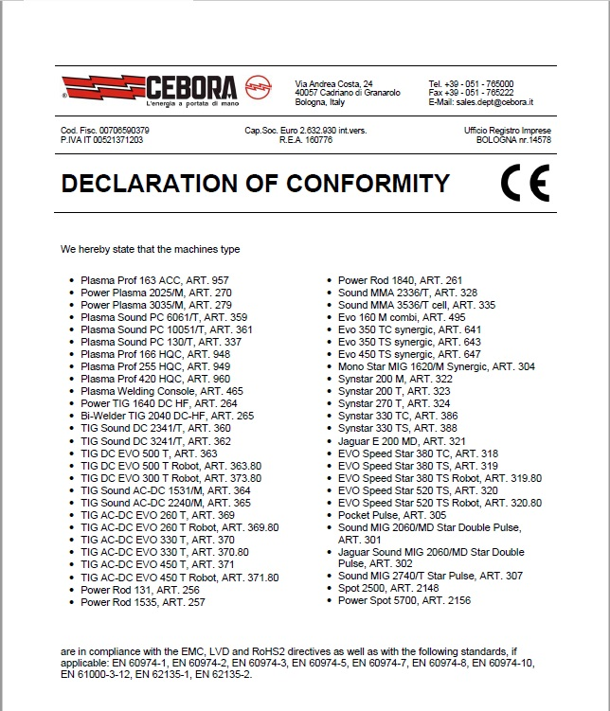

CCC Certificates

"EAC" certificates (Russian approval)

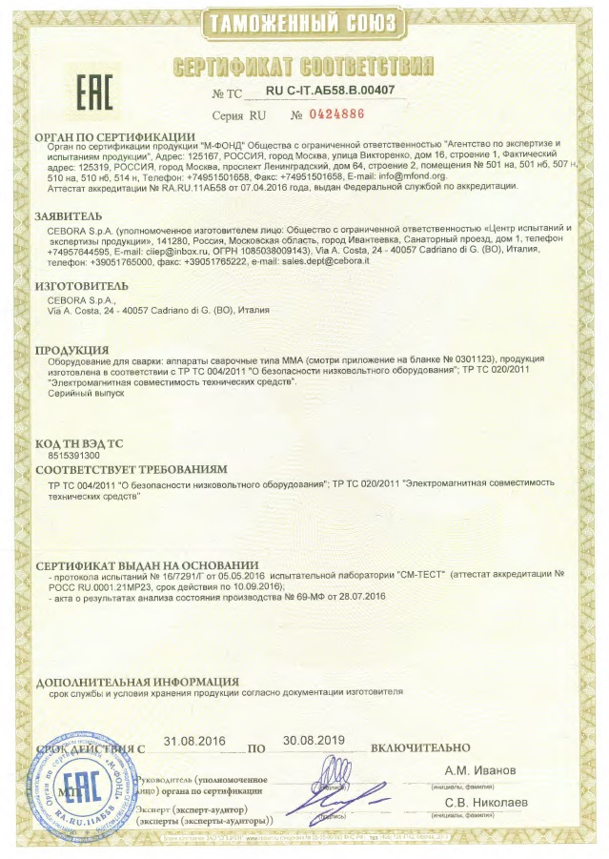

- QUOTATION / TERMS&CONDITIONS

  - QUOTATION

EgyCut6025PW plasma machine | 390000 LE
130A Cebora plasma unit with cutting thickness (pierce 25mm) | included
CNC control system (FLMC) & XB THC-4H | included
Frame Non-standard structure (Completely assembled table) | included
Motors stepper 12N brand Taiwan | included
Type Rails HIWIN Taiwan 25mm First Class | included
Installation Type Bracket for all machine parts | included
Sensors Anti collision | included
Training two weeks | free
NET TOTAL | 390000 LE

  - TERMS & CONDITIONS


DELIVERY TIME : 6 weeks


DELIVERY TERMS : X-WOORKS


PAYMENT TERMS : %60 CASH IN ADVANCE
%40 CASH BEFORE DELIVERY


WARRANTY : 24 MONTHS

- WARRANTY

Unless otherwise species a twenty four (24) months warranty is given for parts and labor for all parts supplied by OFOQ except plasma torch 6 month Warranty. Warranty will commence 2 4 months from date of ship meant on commissioning of machine.

Whichever is the earliest?

In all circumstances unless otherwise agreed to explicitly in writing by “OFOQ” the warranty period will officially begin from the Date of completion of machine commissioning as signed off by our commissioning engineer or from the time of commencement by the purchaser in producing product for sale, if commissioning is not complete. In the case that the system commissioning is delayed for any reason what so ever, the warranty will commence no later than 24 month after the delivery of the equipment. The warranty will be for the period as confirmed in our written confirmation of order.

The following is excluded from the warranty:
- All parts and components which are subject to normal wear due to operation.
- Damages due to non-observance of the operating and maintenance instructions.
- Any damage caused by services e.g. electrical, gas, air water etc, being supplied or connected to the system being incorrect, out of tolerance in supply ranges and or pressures, contamination or in any way being not as recommended by OFOQ
- Any damage caused by failure to Plasma source.
- Any damaged caused by negligence, abuse or incorrect operation. This refers directly to damage caused by untrained or improperly trained personal. Fair wear and tear subject to normal conditions of use.
- Any damage due to lack of maintenance and proper care. In particular failure to follow recommended service schedules and procedures.
- Any items serviced other that by OFOQ or its nominated suppliers. Any service work carried out by the customer or third parties without the express written permission of OFOQ could avoid any items affected by said interference.


To us

: Engineer: Mohamed Shafek

 : - (+2) 01155633911

 : (+2) 01155633911
+201102209464
 : +20235855689

 : ofoq@ofoqcnc.COM _ ofoq2013@yahoo.com

 : https://www.facebook.com/Cebora.egypt

 : https://www.cebora.it/

 : 11 AL-HENEDY ST-MADCOR-AL-HARAM-GIZA



Click here to watch machine video

https://www.youtube.com/watch?v=jsD9s8BoW84&t=6s

